HANOI UNIVERSITY OF SCIENCE AND TECHNOLOGY

School of Information and Communications Technology



Final Project Group Report

**Smartphone E-commerce Website**

Subject: Web Programming

Group 7:

Phạm Văn Khoa – 20176796

Lê Đức Long - 20176806

Nguyễn Mạnh Khang - 20176792

*Hanoi, June 2021*

1. Requirement Analysis

# Introduction

## Objective

This document is to provide detailed information about the development of the Smartphone E-commerce website.

### Product Name: LKK online mobile shop (Smartphone E-commerce website).

### Website overall information:

### LKK online mobile shop is a smartphone e-commerce website that provides customers with a fully functional, responsive website interface. Users can access the website, browse all the products available and simply add to cart any product they want, after filling in all the required information, their order will be successfully received.

For the task of website maintenance and managing, the admin can easily log in with admin’s username and password. After successfully logged in, they can have multiple operations with the database such as edit, add or remove.

# System analysis and design

## General use case diagram

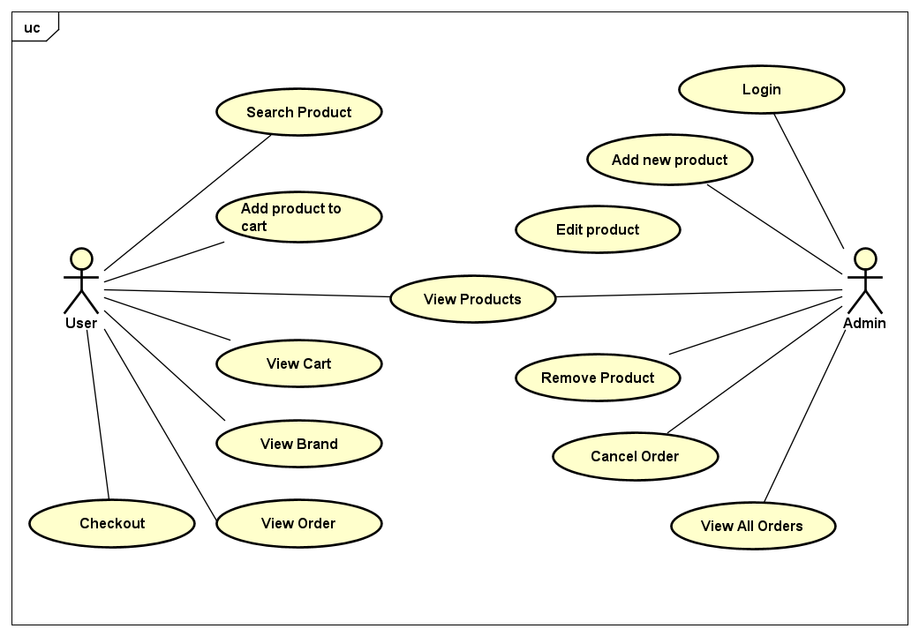

## ER diagram:

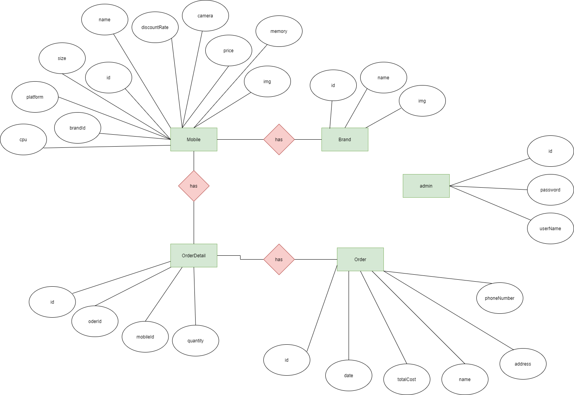

## Class Diagram:

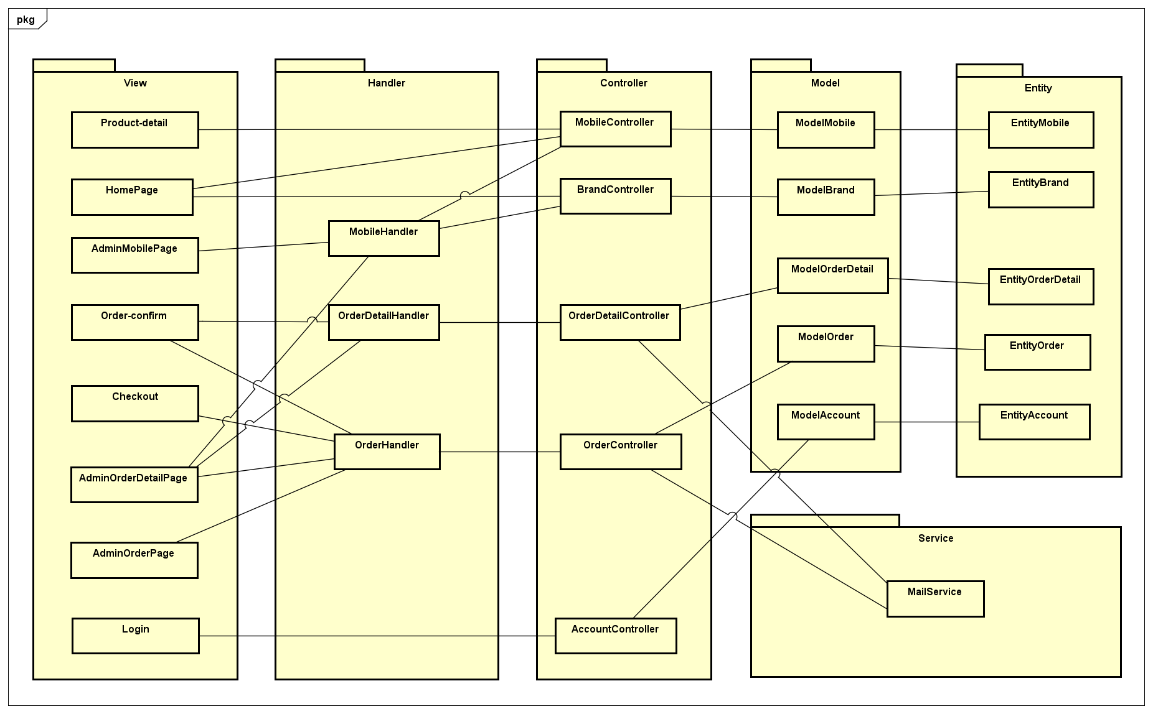

# Technologies Used

## Front-end development:

Our website interface is fully built with just HTML, CSS, and Javascript. No framework or library is used. To be more specific, below are all the technologies used to build the website’s front-end and their corresponding version that we used:

* HTML5
* CSS3
* Javascript 1.7

## Back-end development:

With the development of our website’s back-end, we use all the technologies and languages that we learned during class:

* PHP 7.3.21
* MySQL 5.7.31
* Wampsever64 3.2.3

# Results

Our website has a total number of 6 pages which provided all basic functions for customers.

1. Homepage:

Homepage, which can as well be a product list page with a search bar that provides customers with 4 search criteria including Product name, Brand, Storage size, and Price.

Customers can also access and manage their cart easily by clicking on the cart logo, a cart sidebar will slide in, allow users to remove, or increase the product quantity.

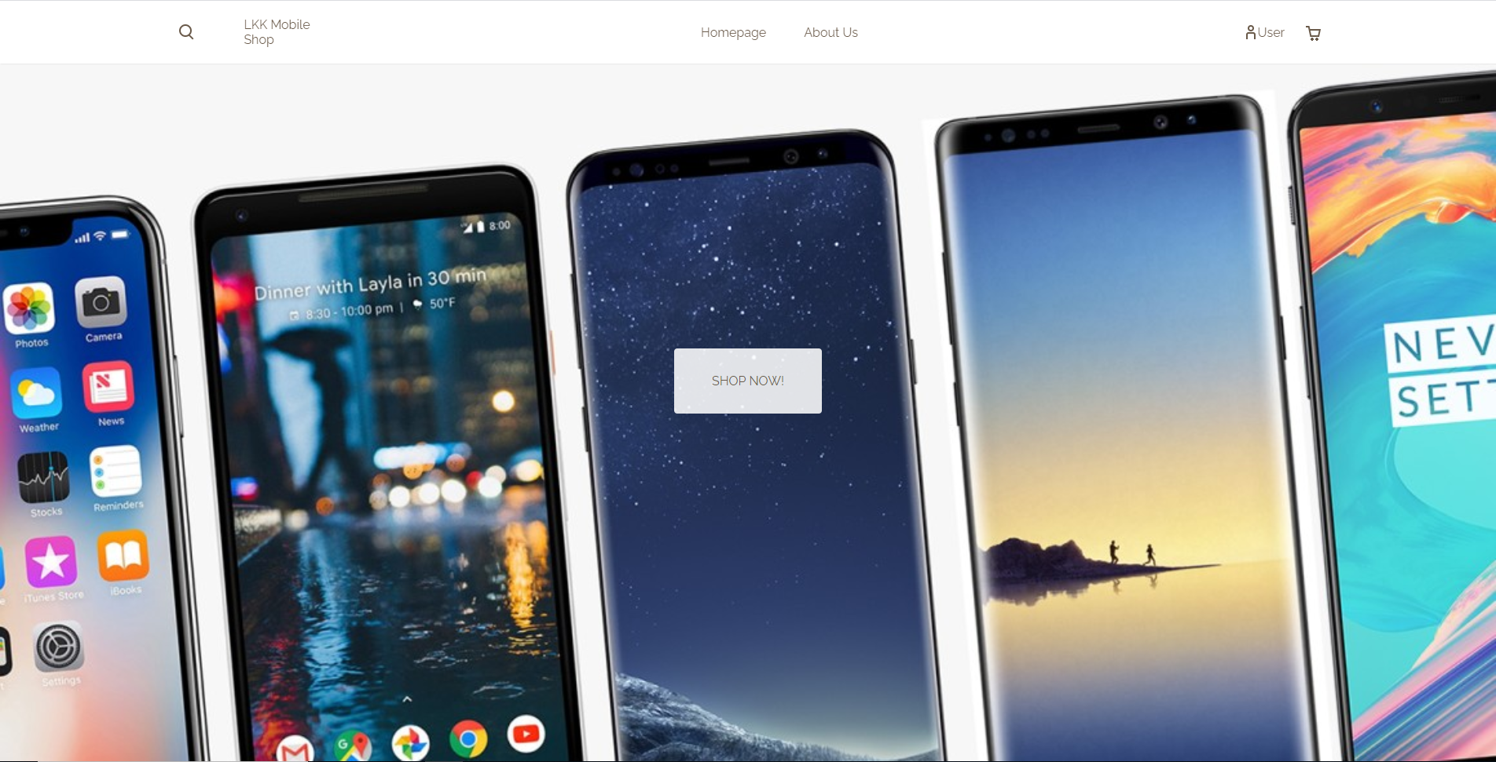

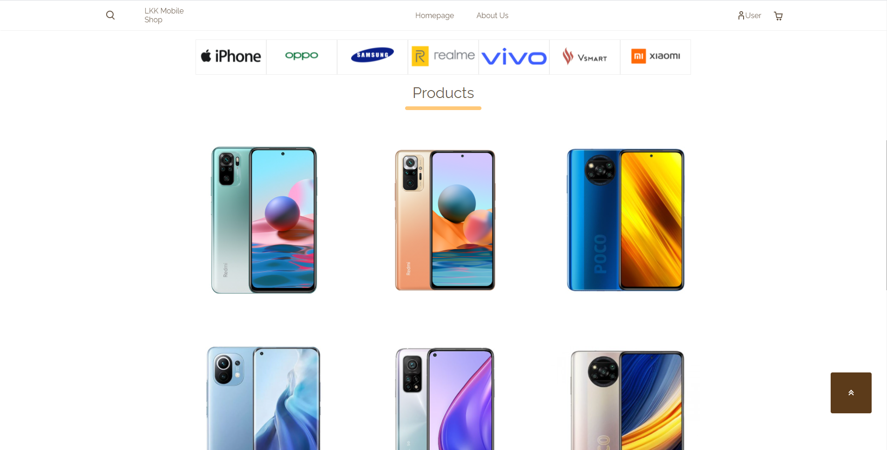

About Us:

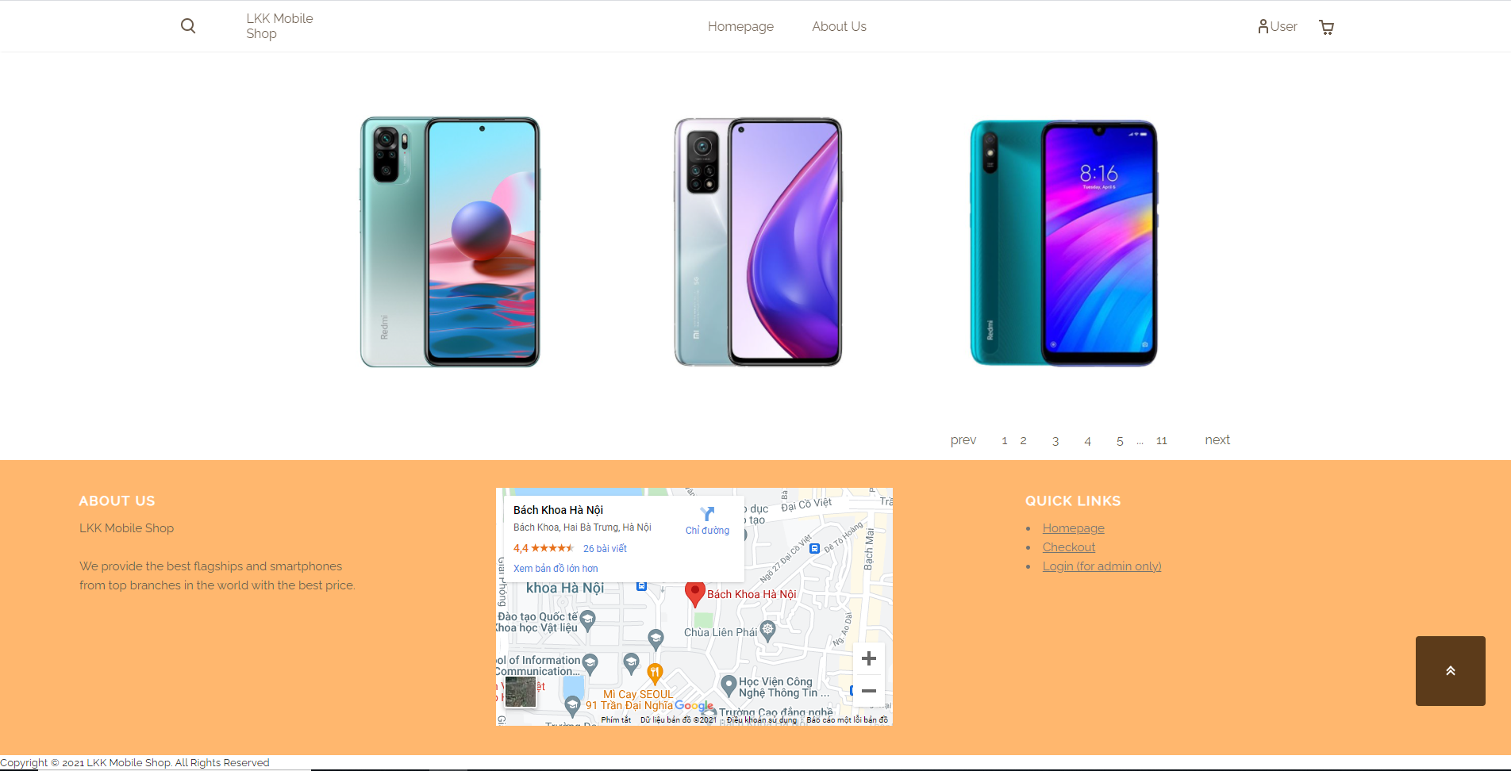

Search Sidebar:

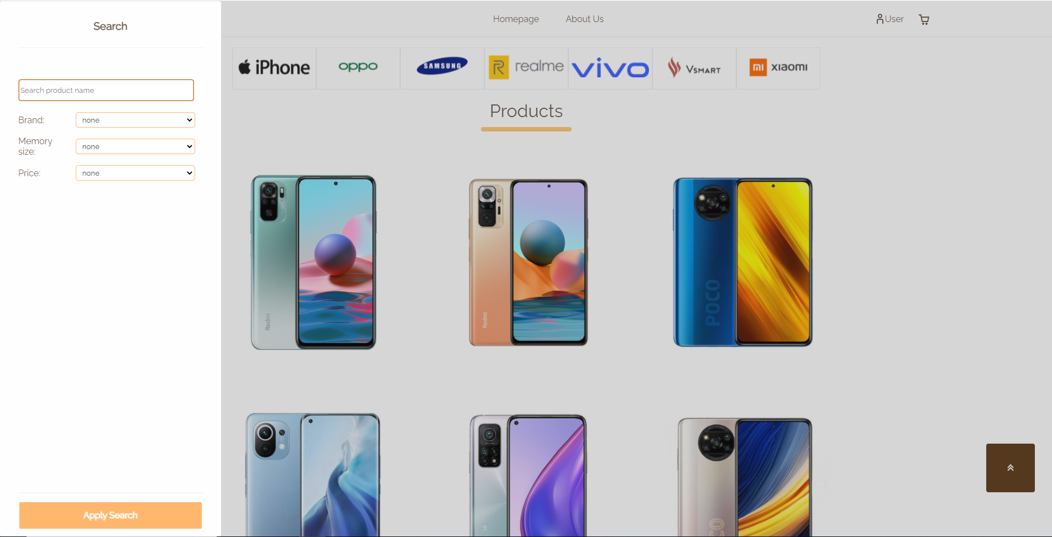

Cart Sidebar:

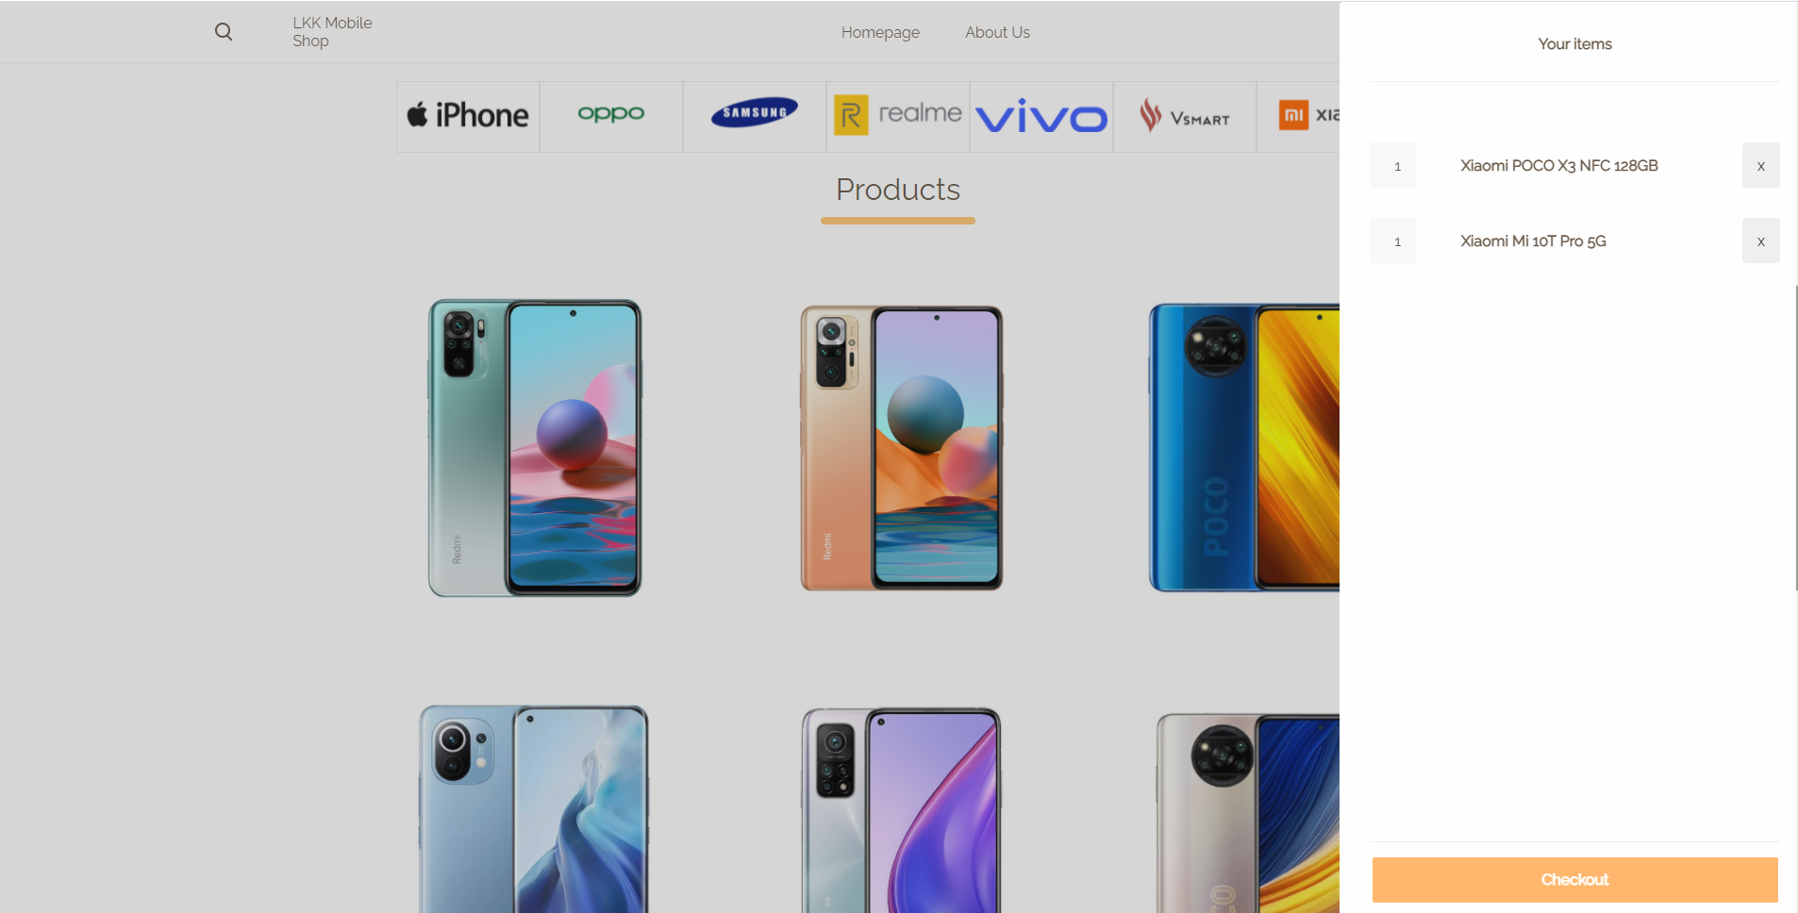

1. Product detail page:

On the product detail page, customers can see product’s information like image, name, price and description including specifications such as platform, chip, front camera, rear camera, screen size, memory size.

Customers can add the product to their cart by simple pick the quantity and click “ADD TO CART” button, and click “BUY NOW” to go to checkout page.

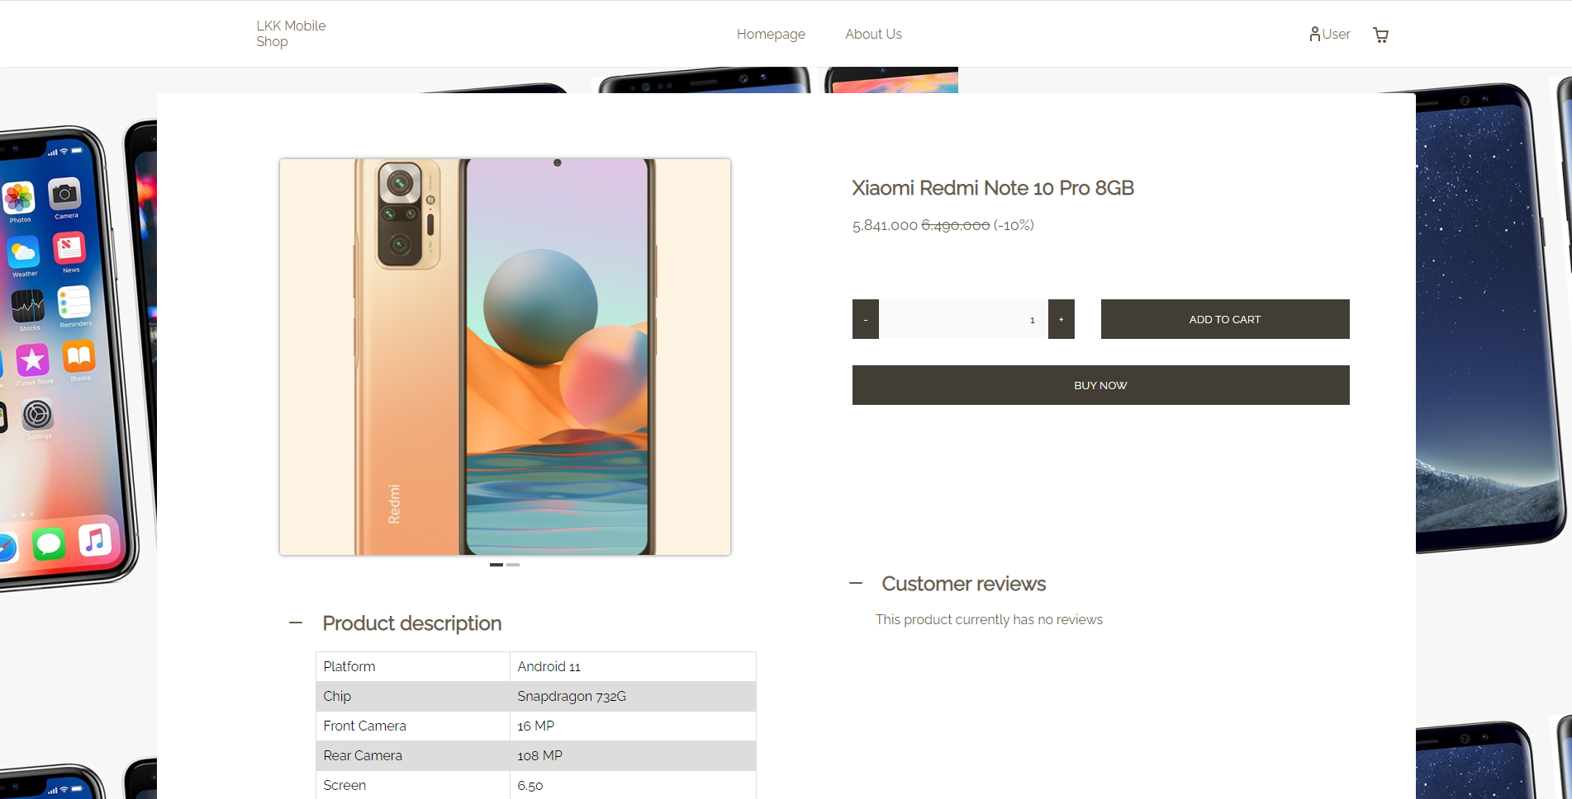

1. Checkout page:

The checkout page basically shows every product that was previously added to cart by customers, and show the total cost of their cart.

On the right side, customers need to fill in all the required information in the form, after that, they can simply click the “PLACE ORDER” button to confirm the order and an email will be sent to the user for confirmation the order.

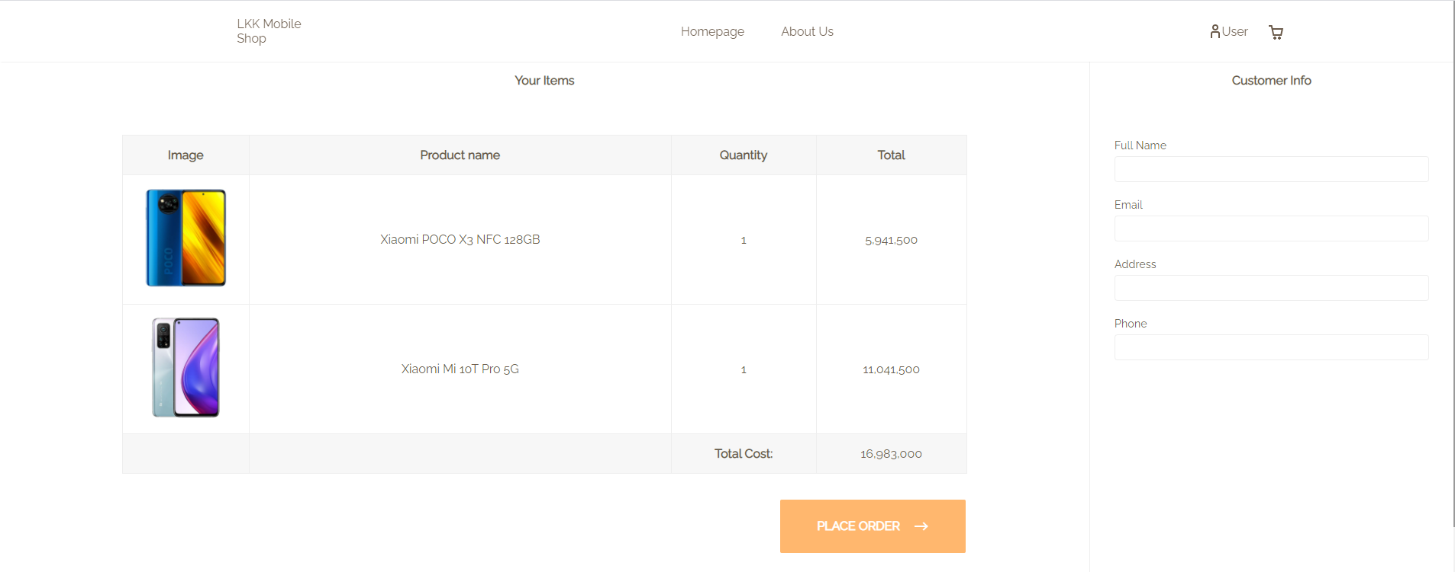

1. Order confirm page:

This page reconfirms that the customer’s order has been successfully received. It shows all the information of the order including product name, total cost, and customer’s information.

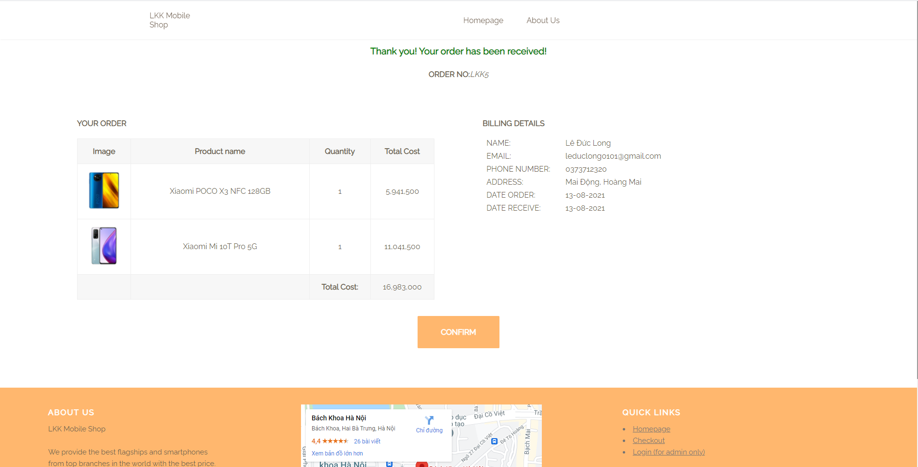

1. Admin login page:

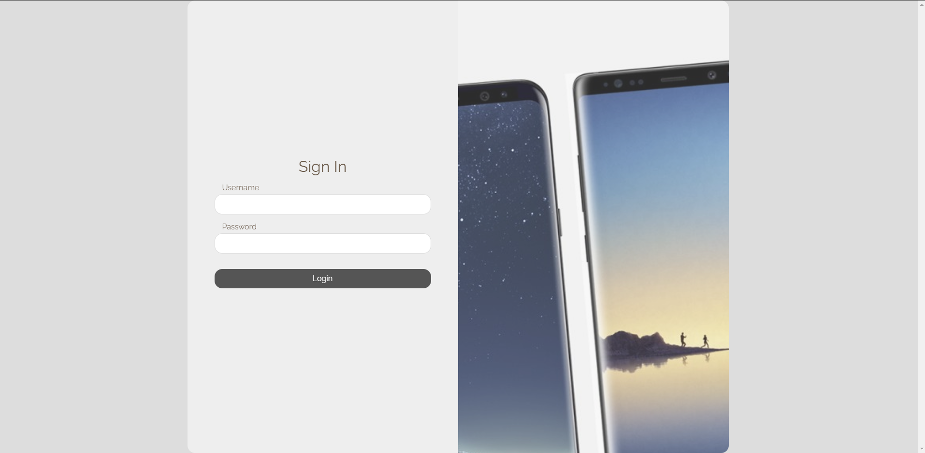

This page allows admins to log in to manage the website’s database.

1. Admin manage products page:

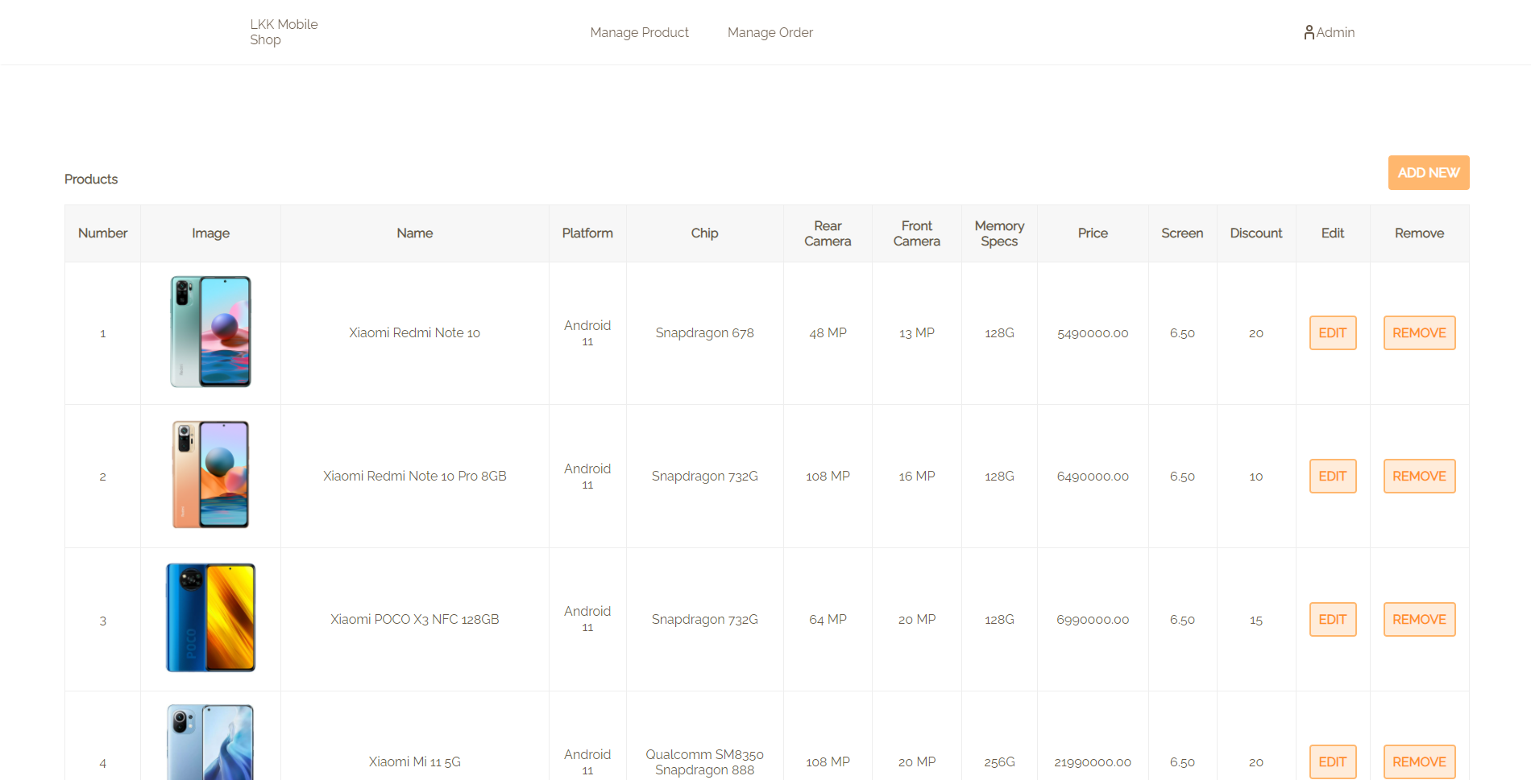

This page allows admins to modify the database with basic operations as Edit, Add and Remove.

Add new product/Edit product:

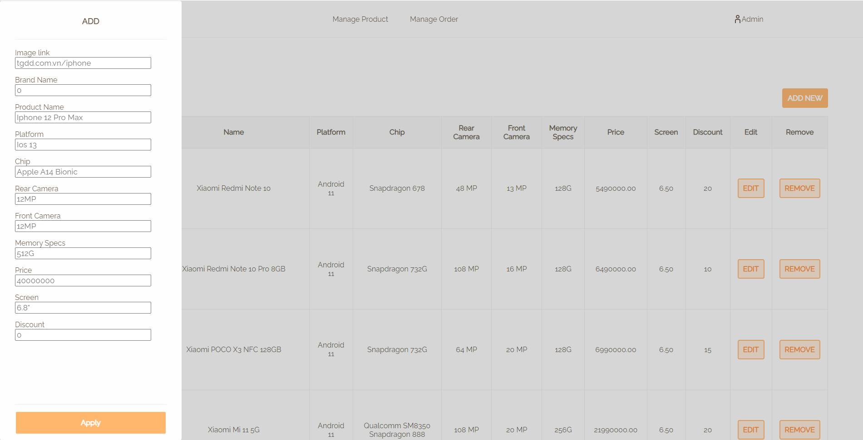

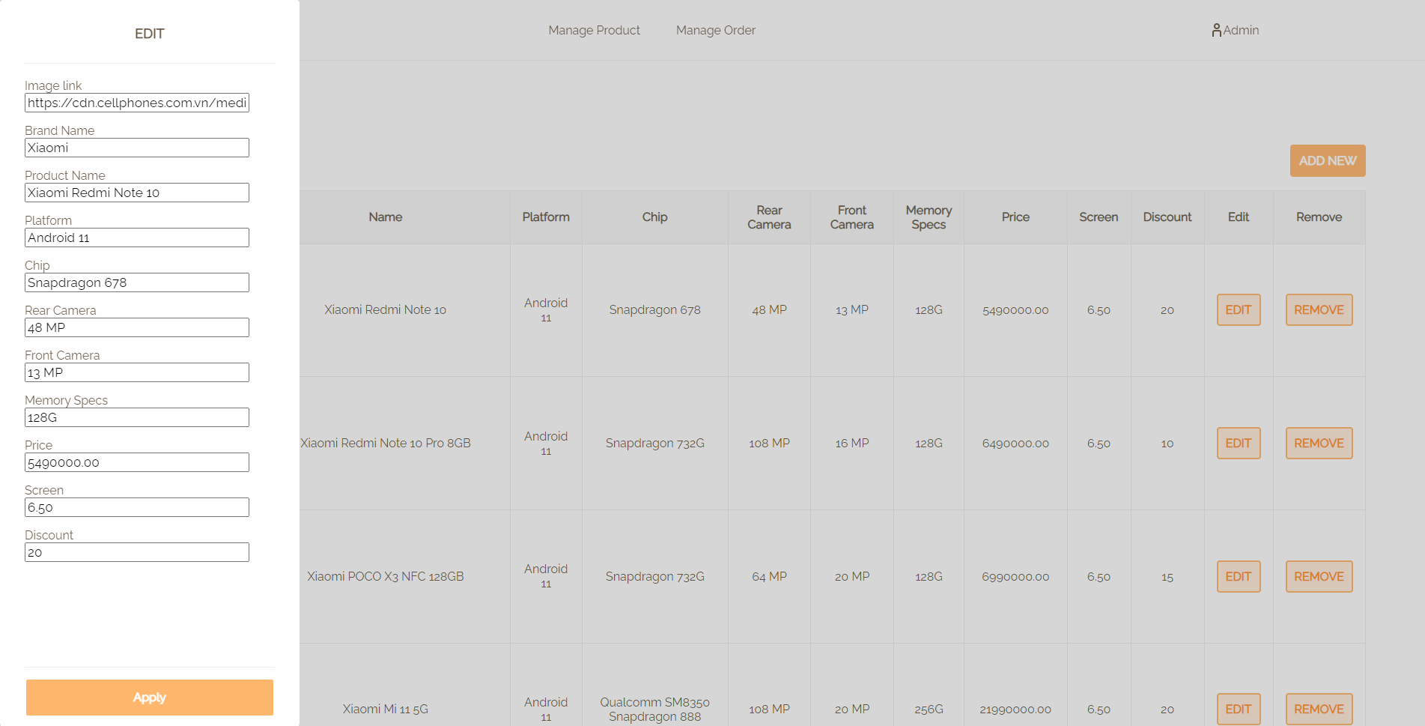

1. Admin manage order page:

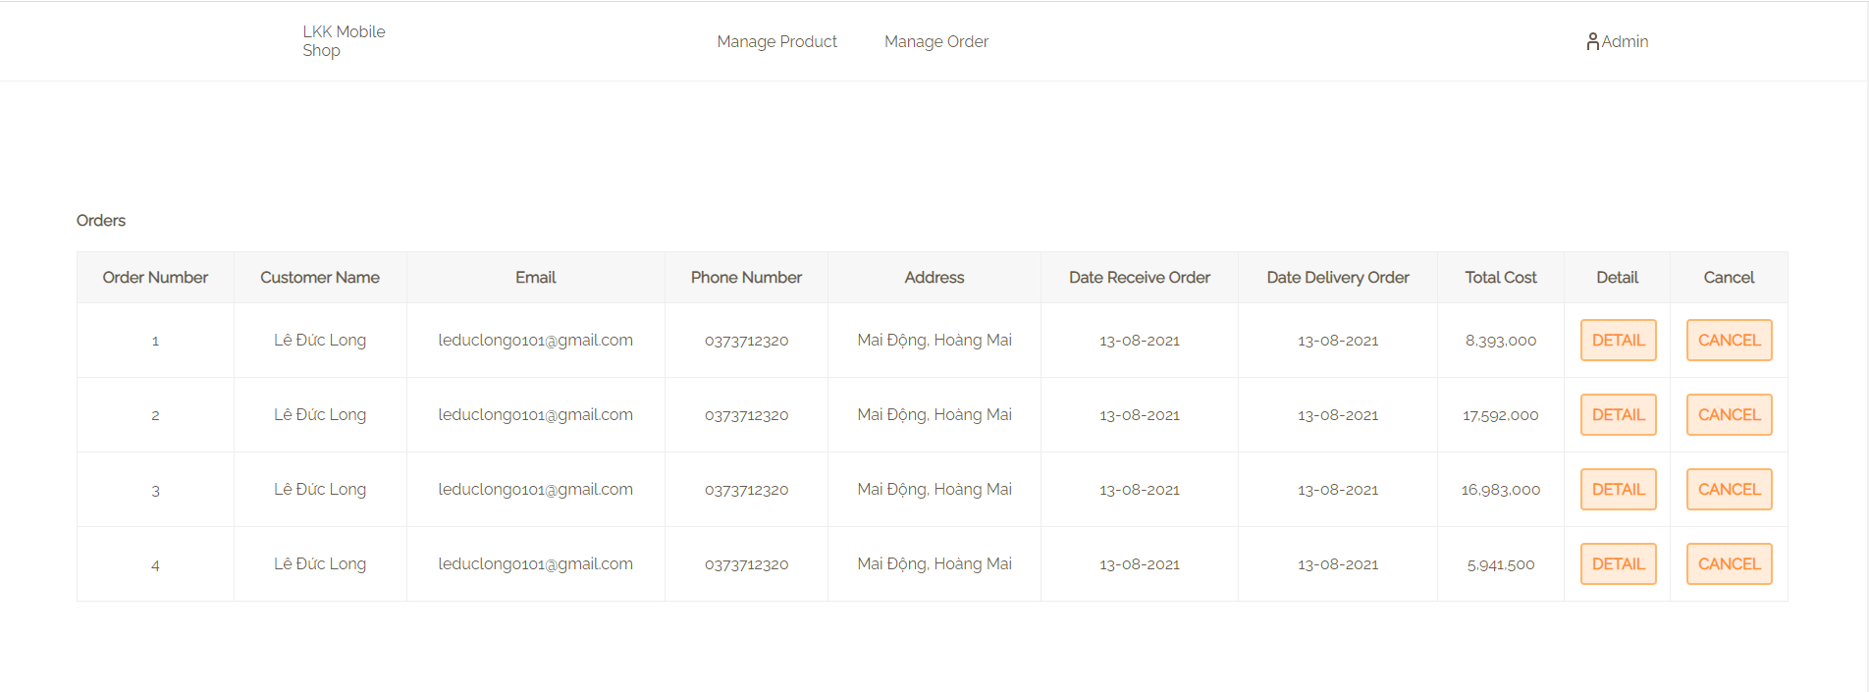

Order detail/Cancel order:

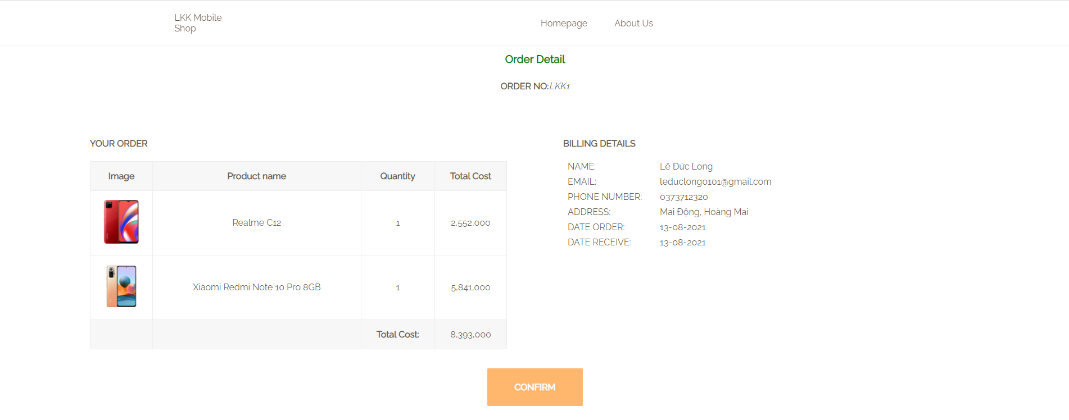

# Difficulties and lessons learned

# Difficulties:

Since all our team members are new to the task of developing a functional website. Besides all the essential knowledge about website programming languages that we acquired during classes such as HTML, CSS, PHP, Ajax, we also need to learn a new language Javascript and its usage. However, we still encountered some difficulties with HTML, CSS.

Because bootstrap and other frameworks and libraries are not allowed, we had a hard time arranging the website’s content, but after days of searching and reading, we found a perfect way to layout the page using “display: flex” in CSS.

Furthermore, we want our website to be flexible and look alive, which led us to learn about Javascript to manage not just animation, but also all basic functions.

Due to the COVID-19 situation recently, our team communication is not as we expected, however, every member always tries their best to be a part of the team and be responsible for the project.

1. **Lessons learned:**

After this, we have learned a lot about the progress of developing a simple e-commerce website, not only the technology but also the specific steps in the task of making a fully functional website. Overall, we have huge improvements in web design thinking, better understanding of HTML, CSS, JS, PHP,… Furthermore, our teamwork skills are better, and the most important thing is to improve our self-study skills.

1. Group Working Assignment

Total time allowed to work and finish developing the Smartphone E-commerce website: 3 months.

Our team has 3 members:

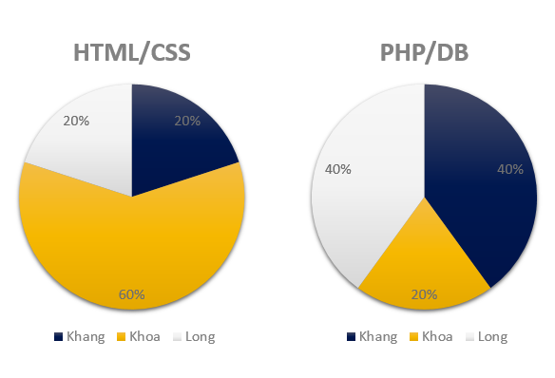

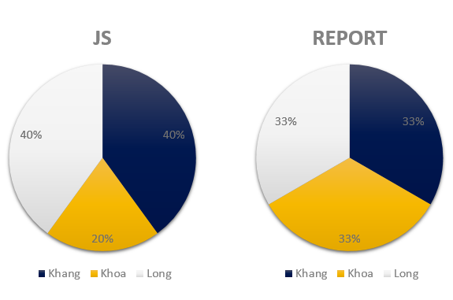

1. Conclusion

* The final result does meet most of our expectations.
* All members did their best for the highest result of the final product.
* We learn many valuable lessons and knowledge from this course.
* Sincerely thanks to our devoted professor for his detailed lessons and most importantly his enthusiasm throughout the course.